Briefing Note – LGA / IDEA Pensions update June 2015
Purpose
- This note summarises the movements between the Pension Fund Balances for the LGA and IDEA since the last Triennial valuation at March 2013, together with the key reasons for the increase in net liabilities shown in the 2014/15 Financial Accounts. In addition the note summarises the key actions being taken to reduce the overall level of deficit.
Current Position
- The table below presents the key values as contained in the Accounts for the Financial Years 2012/13 to 2014/15.
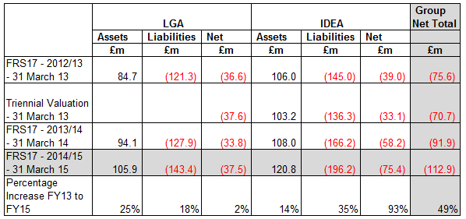
- The main cause of the increase over the last 2 years has been the fall in the discount rate based on the return corporate bonds (4.5% to 3.1%). This has been offset by lower assumptions for the inflation on pensions. For the LGA this has also been offset in the current year by early payment of the deficit contributions to the Merseyside Pension Fund (£1.9m) and the combination the West Sussex and Merseyside Pension Funds (£10.0m)
Plans to cover the deficit
- The LGA and IDEA are currently making additional contributions averaging over £4 million per annum. Actuarial advice indicates that on reasonable long term assumptions, these contributions will be sufficient to eliminate the deficit over a period of 22 years for the LGA and 15 years for the IDeA. In addition the LGA’s Leadership Board has commissioned further work to investigate ways in which the management of the pension deficit can be improved and has agreed to the refurbishment of Layden House from 2016 as part of this strategy.

